



Nursery Prospectus 2017

Nursery Prospectus

**Aims**

Our primary focus is to provide a high quality nursery education for children aged 3-4 in a 26 place nursery class which is part of Scotforth St Paul’s School. We will serve local families and the wider area. We intend to do this by

: Creating a happy, secure environment that is child centred, stimulating and safe.

:Establishing a partnership with parents, supporting them and acknowledging them as the primary carers and educators of their children.

:Planning experiences in the nursery that are fun and appropriate to individual children.

:Employing a trained teacher who is experienced in the Early Years.



Application forms and the terms and conditions are on our website at

[www.scotforth-st-pauls.lancs.sch.uk](http://www.scotforth-st-pauls.lancs.sch.uk) Please ask if you need any help filling in the application.

**Safeguarding**

To ensure all children are protected from abuse and harm, and to promote their right to be strong, resilient and listened to, we are committed to responding promptly and appropriately to all incidents or concerns of abuse and to work with the statutory agencies. We follow the Local Safeguarding Children’s Boards flowchart for referrals; these will be recorded in accordance with school’s Child Protection procedures.

Our Safeguarding and Child Protection policies are freely available on request.

**Location**

We are located on the A6 on Scotforth Road.

**Staff**

To offer the best care and education for your child we believe it is vital to employ staff with a good balance of skills, experience and specialisms.

Mrs Atkinson is a qualified teacher with over 15 years experience working in the Early years in both reception and school nursery classes. She is St. Paul’s School’s Foundation Stage co-ordinator.

Mrs Atkinson is supported by Mrs Todd-Bryce who is a Level 3 qualified teaching assistant.

There is always at least 1 member of staff in the room who is trained in paediatric first aid.

**Settling in Procedure**

We attach great importance to settling your child into nursery. We recommend a minimum of one visit of about an hour in which we ask you to leave your child to begin to get to know us. If you want to know more about visits we would be delighted to help you, please telephone with any further questions or to arrange an appointment to view the nursery. Children can have up to 3 free settling in sessions.

Each child will have a key worker-we will get together with the children in our key groups daily. If you would like to talk with your child’s key worker please ring school on 01524 65379 to make an appointment. You could also send us an email:

Mrs Atkinson [fsks1leader@scotforth-st-pauls.lancs.sch.uk](mailto:fsks1leader@scotforth-st-pauls.lancs.sch.uk)

**Curriculum**

We follow the statutory framework for the Early Years. The Early years foundation stage has 7 areas of learning and development. The nursery and reception staff plan together each half term to provide purposeful activities based around each child’s needs and interests. Staff observe the children and use these observations to plan for the next steps in children’s learning.

Many of the activities are planned around the 3 prime areas of

:communication and language-speaking, listening and understanding.

:physical development-health and self care, small and large scale movements and using tools including pencils.

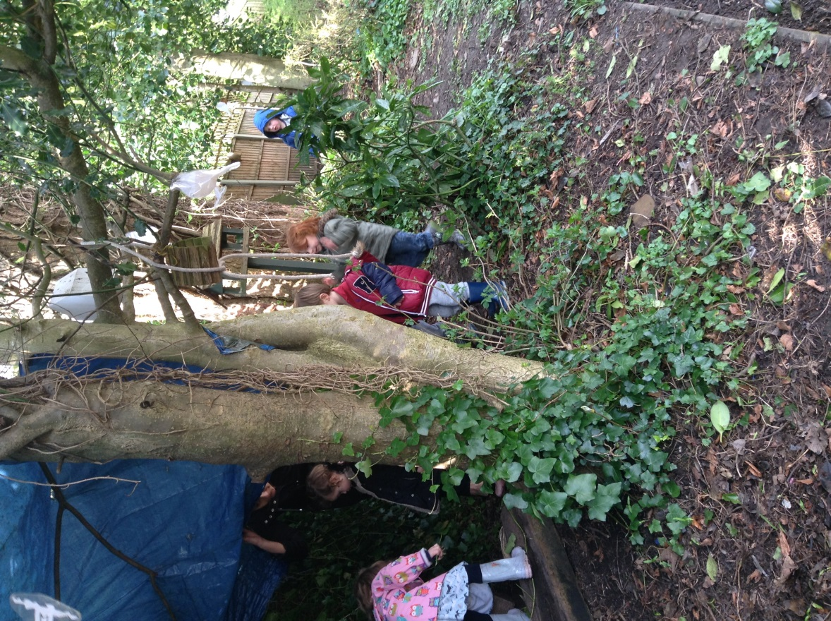

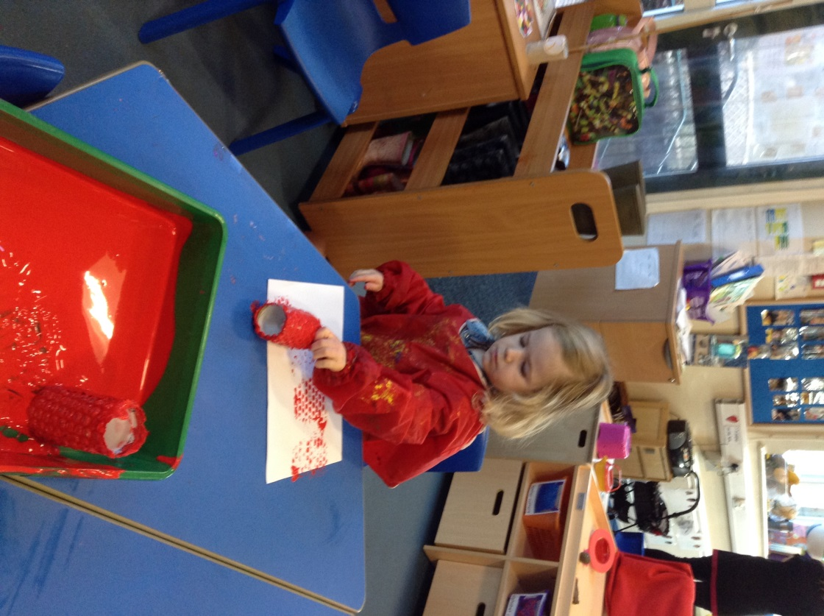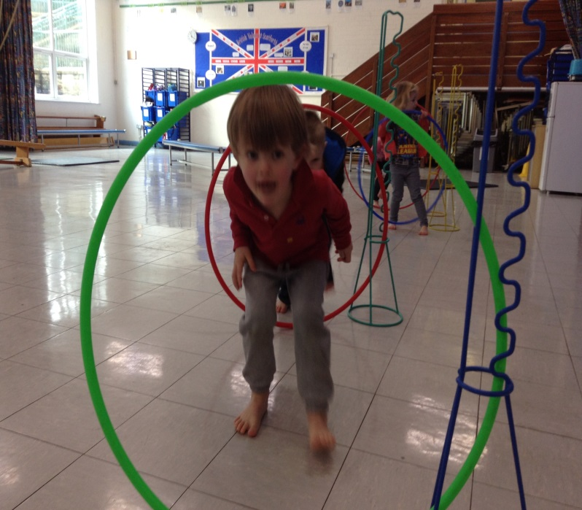

:personal, social and emotional development-self confidence, making relationships and managing behaviour.

Without the skills in these areas children would struggle to access the 4 specific areas of

:literacy-including reading and mark making developing into writing.

:mathematics-including numbers, shape and measures.

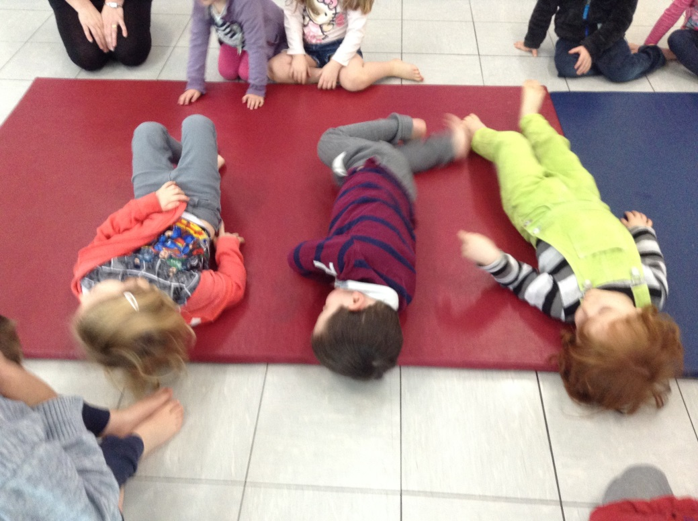

:understanding the world-including technology, animals and plants and the local area.

:expressive arts and design-including making, joining construction toys, art, music, dance and role-play.

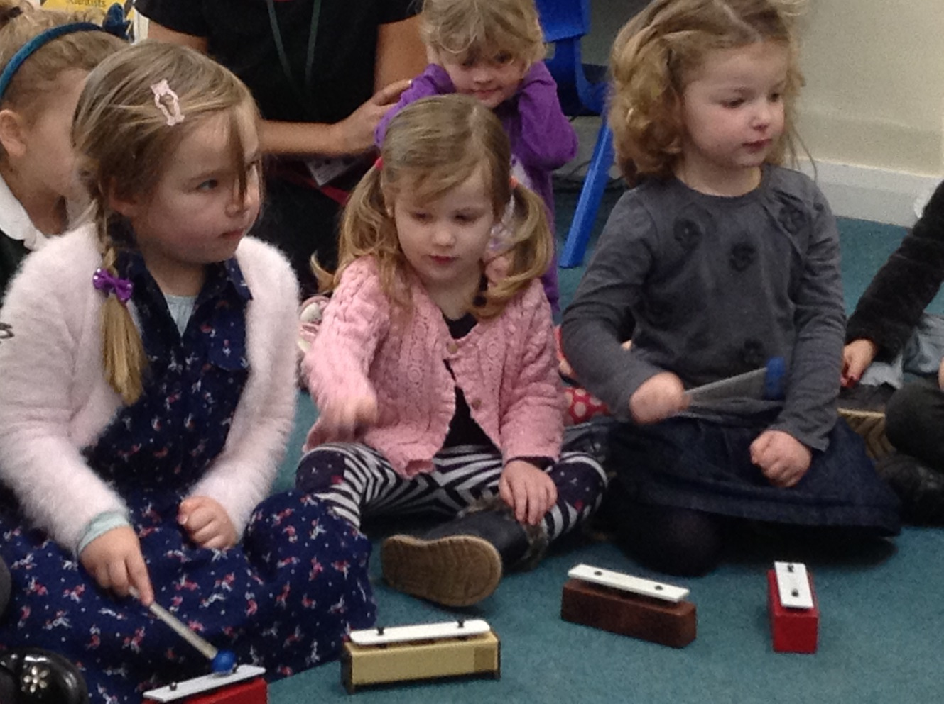

Children will have the opportunity to use both the hall and P.E. facilities and the I.C.T. suite. Children will use the outdoor areas every day and are encouraged to bring a pair of wellies to keep at nursery.

Children will have the opportunity to attend shows, special assemblies and sports days with the school children especially in the 2 terms before they go to school.

Please remember that parents must apply for a place at their chosen primary school in the October before your child starts school. Attending St. Paul’s nursery class does not mean children will receive a place in the reception class.

C:\Users\user\AppData\Local\Microsoft\Windows\Temporary Internet Files\Content.IE5\OEJM4OFM\MC900060286[1].wmfC:\Users\user\AppData\Local\Microsoft\Windows\Temporary Internet Files\Content.IE5\U1Q5DL0V\MC900324518[1].wmfC:\Users\user\AppData\Local\Microsoft\Windows\Temporary Internet Files\Content.IE5\OEJM4OFM\MC900440524[1].wmf

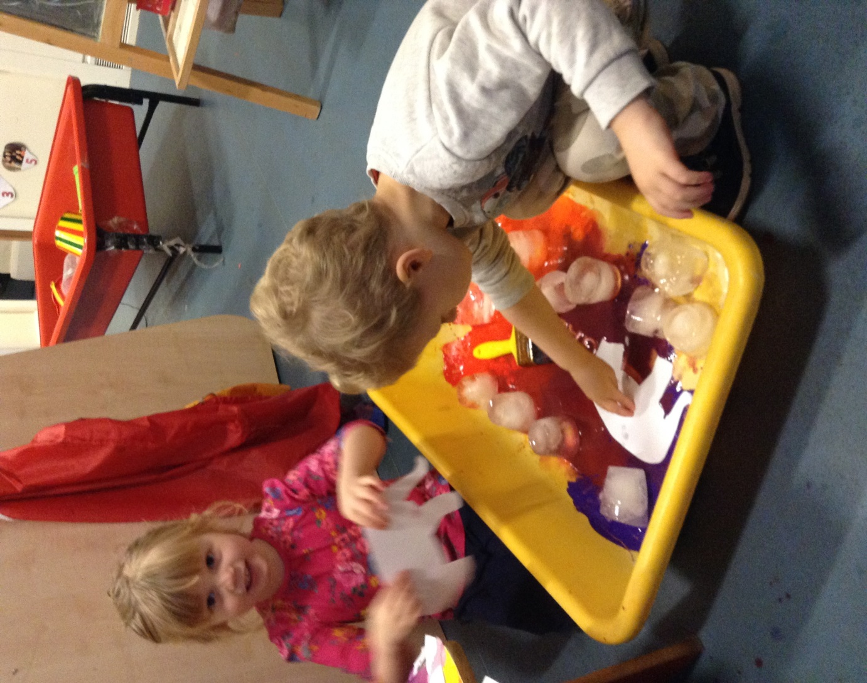

**Sessions and fees**

**Nursery is open for 38 weeks of the year (term time) It is possible to book nursery aged children into the holiday play scheme at school which operates for a further 9 weeks a year.** Please see Scotforth After School Club prospectus for details of their terms and conditions.

Morning sessions 8:45am to 11:45am

Afternoon sessions are 12:30pm to 3:30pm.

Children can attend from the term after their third birthday for up to15 hours per week using the government free universal 15 hours of childcare. You may choose to take up to 5 mornings, 5 afternoons or 2.5 full days which would ideally be Monday all day, Tuesday all day and Wed morning. Or Wed afternoon, Thursday all day, Friday all day. Children who will turn 3 in a term are known as “rising 3’s” and can start Nursery with a fee paying place.

Starting in September 2017 the government are introducing a further 15 hours of free childcare for working parents. Parents can check if they are eligible for this extra funding by going on the new “Childcare choices” website.

There is the option to pay for further sessions including lunchtimes, before school care and after school care.

Sometimes an extra session is needed in a week. If we have the space we will try to accommodate requests.

Breakfast club from 7:45am-8:45am £3.75 (In the school hall but run by Scotforth ASC)

Morning or afternoon session £13.50

Lunch club from 11:45am-12:30pm £1.50 if children bring a packed lunch or £3.70 if children have a hot dinner. (If you feel you are entitled to free school meals please let us know.)

After school club from 3:30pm until 6:00pm £7.50.

Full day 8:45am to 3:30pm £28.50

Full day with wrap around care 7:45am to 6:00pm £39.75

Fees are paid in advance with bills being sent out on the first of the month for the month ahead. The first months fees are payable in advance unless you are accessing the 15 hours free funding only. Bills can be paid by cash or cheque. Ask us about paying online.

On accepting a place you will be asked to sign permissions for the taking and displaying of photographs of your child, emergency treatment, first aid, application of sun cream and outings from nursery in the local area.

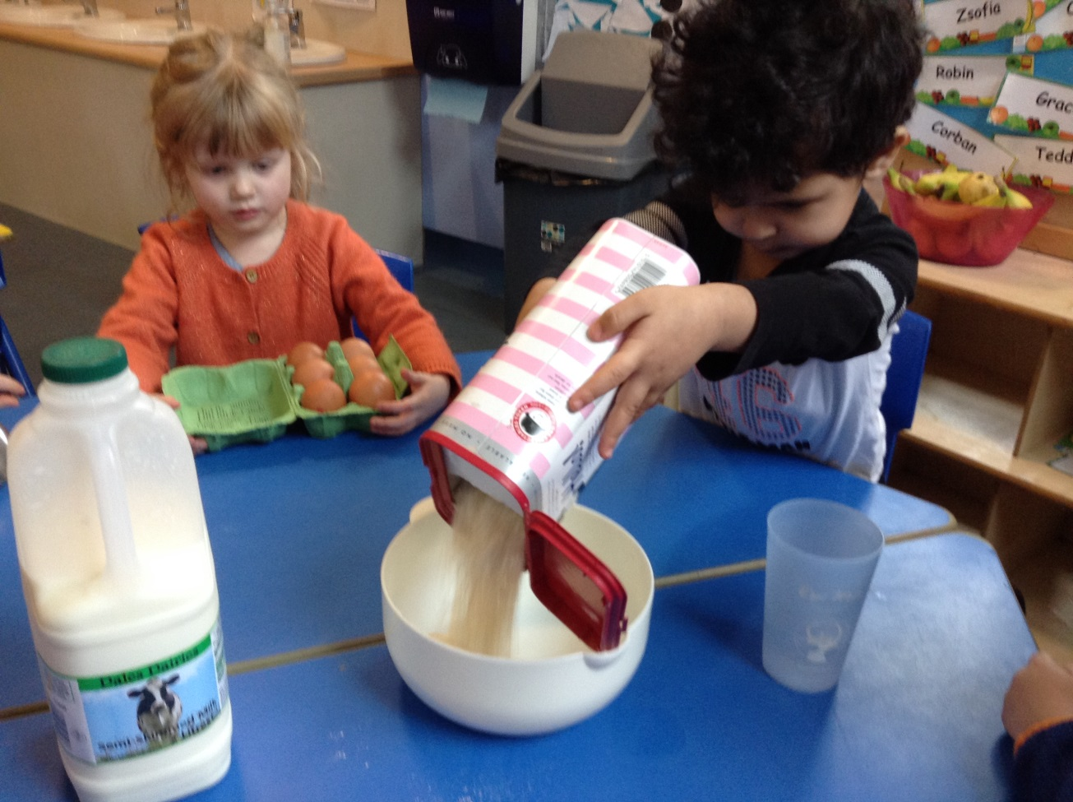

**Help with childcare costs**

The government funds 15 hours of education per week for 38 weeks of the year beginning the term following your child’s third birthday. This is known as “Universal” funding. Most working parents will be able to access a further 15 hours a week which can be split between up to 2 providers a day. This “extra” funding can be used at Breakfast clubs and after school clubs and for holiday childcare. Parents apply for this funding online and will receive an 11 digit code to bring into Nursery.

Child tax credit-This is paid into the bank account of the main person in your family who is responsible for looking after the children. Child tax credit is available to families with an income up to £43,000 whether or not they are working.

Working tax credit-Help is available for parents who work through the Working Tax Credit, part of which helps with the costs of childcare. You can get more information on either credit online at [www.inlandrevenue.gov.uk/taxcredits](http://www.inlandrevenue.gov.uk/taxcredits)or ring the helpline on 0845 300 3900.

Childcare vouchers-Employers can offer their employees childcare vouchers worth up to £243.00 per month, free of standard rate of tax and National Insurance contribution operated through a salary sacrifice scheme. For more details got to [www.childcarevouchers.co.uk](http://www.childcarevouchers.co.uk)

**Food/snacks/drinks**

Drinks of water and milk are available on demand throughout the day. Children are encouraged to drink plenty of water, especially in warm weather.

To safeguard your child’s teeth, we aim to limit the consumption of sugar. Our snacks include lots of fresh fruit and vegetables. Children are not allowed to bring sweets or chocolate to eat at nursery. Please talk to us about your child’s allergies or any special dietary needs.

Children who are staying for lunch can bring a packed lunch will be eaten in the school Hall. The nursery children sit together with a L3 teaching Assistant.

Children can have a hot dinner at a price of £2.20 per day. 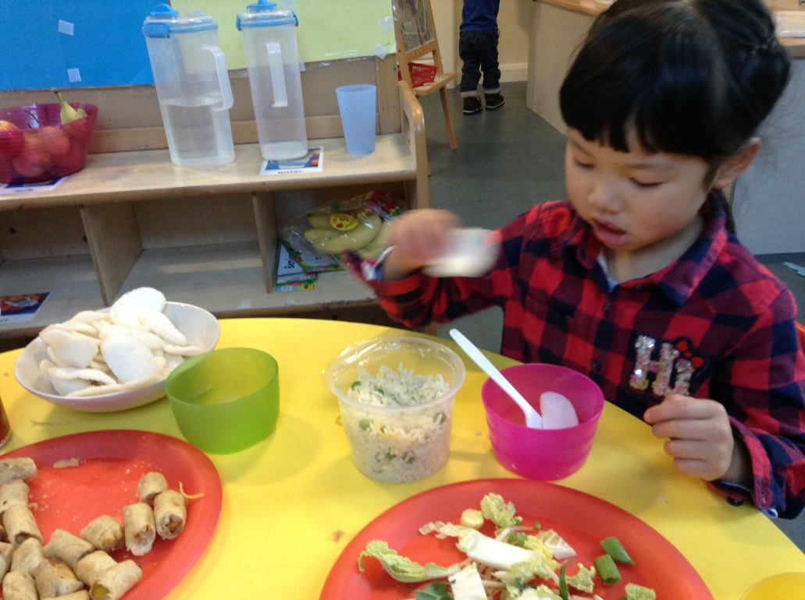

**Security of children**

For the safety of all the children in our care the nursery gate is open until 9:00am only before being shut by a member of staff. The gate reopens at 11:40 am for parents collecting children from the morning session and then is open at 12:25pm until 12:35 for parents bringing children to the afternoon session. The gate unlocks again at 2:45pm for parents picking up children from reception and will stay unlocked until 3:35 pm for parents of nursery children. A member of staff will let parents in through the classroom door and will stay at the door until all children are collected. During the day when the gate is locked children will have access to the outdoors with a member of staff.

Under no circumstances will we allow your child to be collected by anyone not authorised by you. Proof of identity or a password will be required from anyone unfamiliar to us. We will not allow anyone under the age of 16 to collect your child.

**Clothing and nappies**

Most children at 3 years old are already using a toilet. Within the nursery class are infant sized toilets. If a child has an accident we will provide spare clothes that need to be washed and returned as soon as possible. If your child still wears nappies please inform us before they start nursery and we will work together on toilet training.

Children must wear clothing that they can remove and dress themselves in including their socks and shoes. A coat must be brought each day. In summer a sun hat must be provided that is to be left in school. All clothes should be named. If you have signed the consent form we will support children in applying sun cream on arms, legs and faces.

**Illness and infection**

Due to the risks of cross-infection in a nursery environment, if your child is suffering from an infectious illness, including Measles, German Measles, Chicken Pox, Conjunctivitis, Thrush, Impetigo, Scarlet fever etc. he or she must not attend nursery until the infection has cleared. Please ask for latest health service advice. If your child is suffering from sickness or diarrhoea then they must not return to nursery for 48 hours after beginning to feel well again.

Please make sure all contact details are up to date in case we need to ring you in case of an accident or illness.

**Prescribed Medication**

We will only give your child medication that is prescribed by a GP. Please fill in a form from the school office if your child needs medication during the day including inhalers. Medicine will only be given if it is in its original container with the child’s name on.

**First Aid and Emergency treatment**

When your child starts nursery we will ask you for written permission to administer first aid treatment if necessary, and for permission to take your child to hospital, by car or ambulance in an emergency.

C:\Users\user\AppData\Local\Microsoft\Windows\Temporary Internet Files\Content.IE5\XTF16ESN\MC900040186[1].wmfC:\Users\user\AppData\Local\Microsoft\Windows\Temporary Internet Files\Content.IE5\OEJM4OFM\MC900048228[1].wmfC:\Users\user\AppData\Local\Microsoft\Windows\Temporary Internet Files\Content.IE5\U1Q5DL0V\MC900251781[1].wmf

**Access to records**

Parents are welcome to see any written records we hold on their child. Children’s learning journeys are in children’s trays and may be taken home at any time.

**News**

We have a board in the outdoor area for all parents of children in the foundation stage with newsletters, photos etc. You are welcome to come to school functions and are automatically a member of FOSSY our PTA. The nursery has its own area on the school website under “classes.” [www.scotforth-st-pauls.lancs.sch.uk](http://www.scotforth-st-pauls.lancs.sch.uk)



**Application for a Nursery Class place**

|  |  |
| --- | --- |
| Child’s Full Name: | Child’s Date of Birth:  Child’s Gender: |

|  |
| --- |
| Parent / Guardian’s Full Name:  Address  Postcode:  Home Telephone:Work Telephone:  Mobile:Email: |

|  |
| --- |
| **Intended Start Date** (if not September 2017)*:  *ie. If your child has their 3rd birthday between September and December 2017 |

|  |
| --- |
| **Criteria* under which the place is being applied for**  □Child in public care □Medical/social need □Faith □Sibling □Distance  *Please refer to the Nursery Class Admissions Policy and tick as appropriate. These criteria will be applied if the nursery is over subscribed. A supplementary form must also be completed if applying under the faith criteria (criteria 2). |

|  |
| --- |
| **Free Entitlement Vouchers for Preschool Children (aged 3 to 4 years)**  Would you like to use your Universal free 15 hours: Yes / No  Are you eligible for the extra 15 hours Yes/No  Will you be splitting your hours with another provider Yes/No  Please tell us here how many hours you will be using with each provider……………… |

|  |
| --- |
| **Workplace Childcare Vouchers**  Would you like to use Workplace Childcare Vouchers: Yes / No  If yes, which scheme do you intend to use? |

|  |
| --- |
| Do you think your child might be entitled to pupil premium funding? Yes/No  Please ask Nursery staff if you are not sure. |

|  |
| --- |
| Is your child in receipt of DLA? Yes/No  If yes this funding gives Nursery £615 a year to support children e.g. with specialist equipment. |

Please indicate on the form below, which sessions you would like your child to attend.

**Free Entitlement vouchers**

Government universal funded places are available for a total of 15 hours. You could choose either:

* 5 morning sessions/week
* 5 afternoon sessions/week
* 2 ½ days (Monday, Tuesday, Wednesday morning) or
* 2 ½ days (Wednesday pm, Thursday, Friday)

We will try to accommodate other session patterns, subject to availability.

Please indicate these on the form by inserting a **U** on the appropriate sessions.

Working parents extra 15 hours funding may be spread between nursery, breakfast club and after school club. Please indicate these with an **E** on the form

**Top-up sessions**

Should you require more hours, you have the option to apply for top-up sessions, which will be charged at the following rates and will be subject to availability:

* Morning session (8:45am-11:45am) £13.50
* Afternoon session (12:30pm-3:30pm) £13.50
* Whole day (8:45am-3:30pm) £28.50 (including lunchtime care)
* Lunchtime care (11:45am-12:30pm) £1.50

Please indicate these on the form by inserting a **T** on the appropriate sessions.

|  |  |  |  |  |  |
| --- | --- | --- | --- | --- | --- |
|  | Monday | Tuesday | Wednesday | Thursday | Friday |
| Breakfast Club*  7:45am-8:45am |  |  |  |  |  |
| Morning session  8:45am-11:45am |  |  |  |  |  |
| Lunchtime  11:45pm-12:30pm |  |  |  |  |  |
| Afternoon session  12:30pm-3:30pm |  |  |  |  |  |
| After-school Club*  3:30pm-6pm |  |  |  |  |  |

*Breakfast Club and After-school Club are provided by Scotforth After School Club under the leadership of Marie Smith (whose Ofsted registration includes 3 and 4 year olds). These sessions are available at a cost of £3.75 for Breakfast Club and £7.50 for After-school Club. Please see their prospectus for further information.

|  |
| --- |
| If we are unable to offer you the requested sessions can we offer you alternatives? Yes/No  Details: |

|  |
| --- |
| Signature of Parent / Guardian  Date: |